Week-05 HandsOn Solution

- JWT Microservices

Question 1: Implement JWT Authentication in ASP.NET Core Web API

- Code:

using System;

using JwtMicroservice.Models;
using Microsoft.AspNetCore.Mvc;
using Microsoft.IdentityModel.Tokens;
using System.IdentityModel.Tokens.Jwt;
using System.Security.Claims;
using System.Text;

namespace JwtMicroservice.Controllers
{
[ApiController]
[Route("api/[controller]")]
public class AuthController : ControllerBase
{
[HttpPost("login")]
public IActionResult Login([FromBody] LoginModel model)
{
if (IsValidUser(model))
{
var token = GenerateJwtToken(model.Username);
return Ok(new { Token = token });
}

return Unauthorized();
}

private bool IsValidUser(LoginModel model)
{
return model.Username == "admin" && model.Password == "password";
}

private string GenerateJwtToken(string username)
{
var claims = new[]
{
new Claim(ClaimTypes.Name, username),
new Claim(ClaimTypes.Role, "Admin")
};

var key = new SymmetricSecurityKey(
Encoding.UTF8.GetBytes("ThisIsASecretKeyForJwtToken"));
var creds = new SigningCredentials(key, SecurityAlgorithms.HmacSha256);

var token = new JwtSecurityToken(
issuer: "MyAuthServer",
audience: "MyApiUsers",
claims: claims,
expires: DateTime.Now.AddMinutes(60),
signingCredentials: creds);

return new JwtSecurityTokenHandler().WriteToken(token);
}
}
}

- Output:

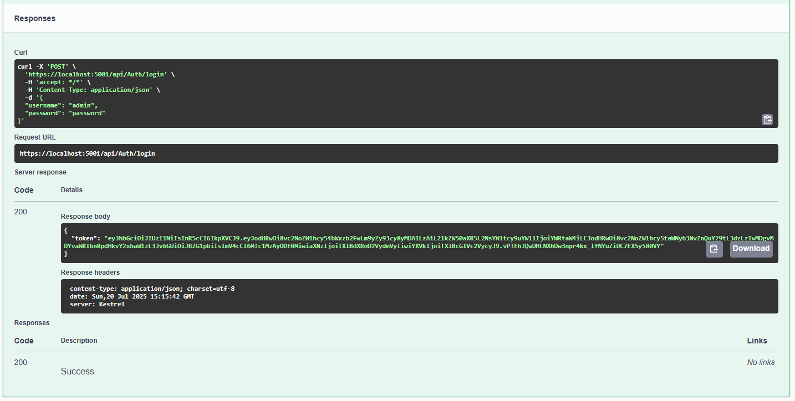

Question 2: Secure an API Endpoint Using JWT

- Code:

using Microsoft.AspNetCore.Authorization;
using Microsoft.AspNetCore.Mvc;

namespace JwtMicroservice.Controllers
{
[ApiController]
[Route("api/[controller]")]
public class SecureController : ControllerBase
{
[HttpGet("data")]
[Authorize]
public IActionResult GetSecureData()
{
return Ok("This is protected data.");
}
}
}

- Output:

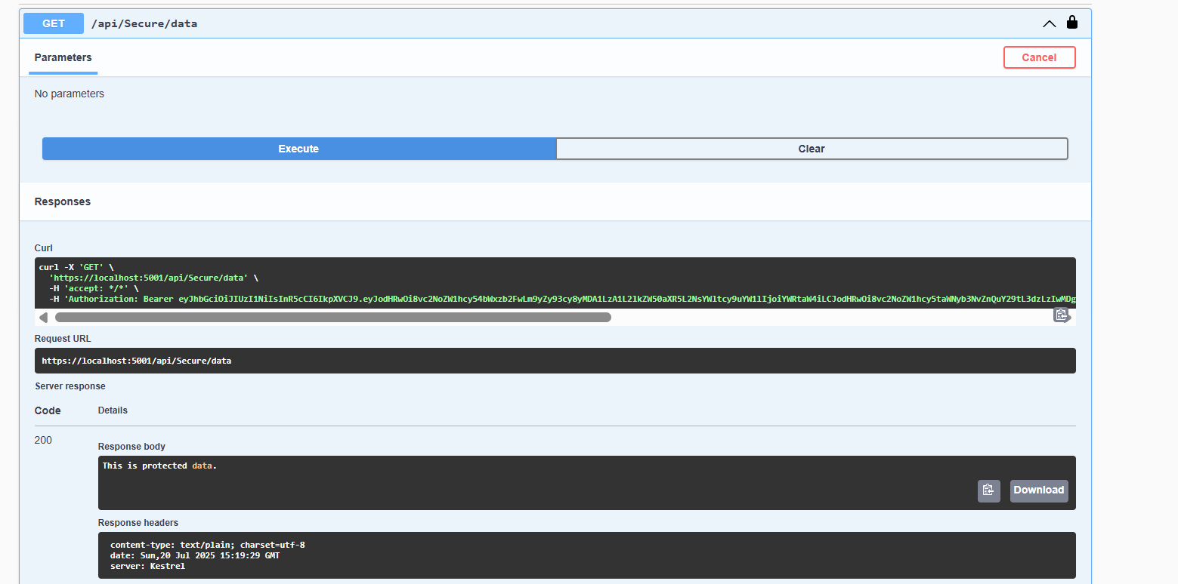

Question 3: Add Role-Based Authorization

- Code:

using Microsoft.AspNetCore.Authorization;
using Microsoft.AspNetCore.Mvc;

namespace JwtMicroservice.Controllers
{
[ApiController]
[Route("api/[controller]")]
public class AdminController : ControllerBase
{
[HttpGet("dashboard")]
[Authorize(Roles = "Admin")]
public IActionResult GetAdminDashboard()
{
return Ok("Welcome to the admin dashboard.");
}
}
}

- Output:

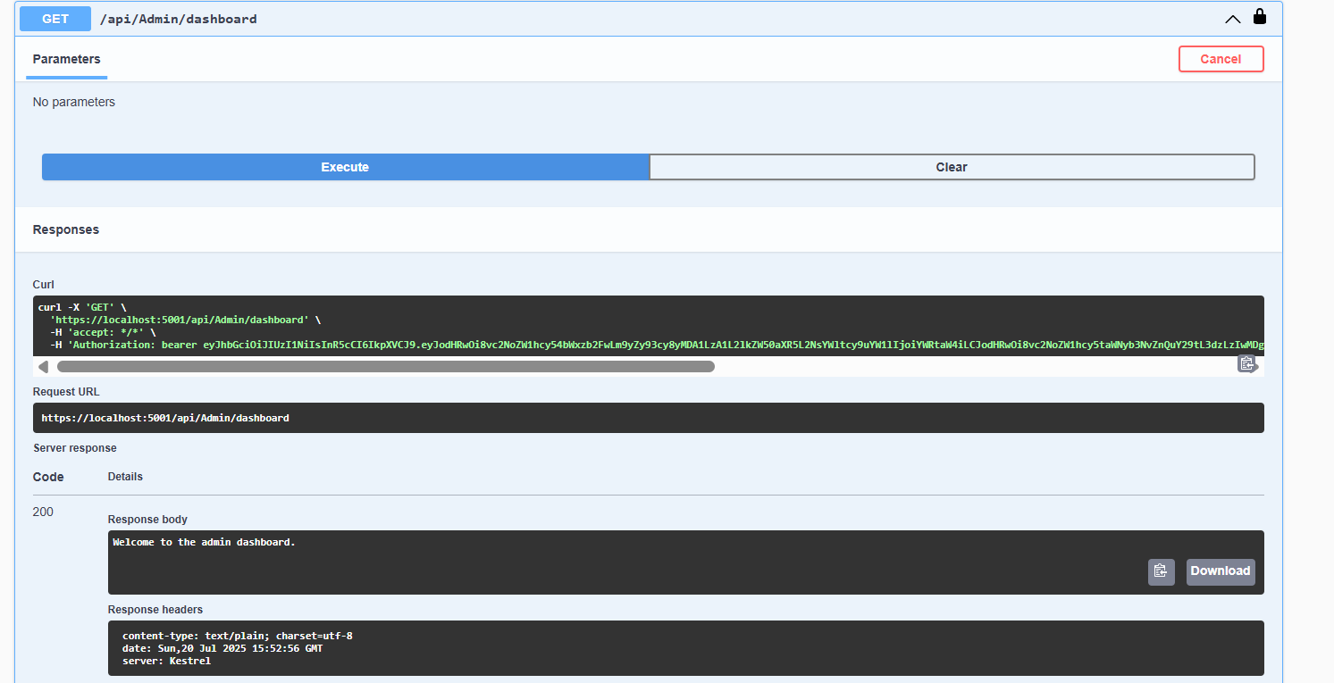
Question 4: Validate JWT Token Expiry and Handle Unauthorized Access

- Code:

using Microsoft.AspNetCore.Authentication.JwtBearer;
using Microsoft.IdentityModel.Tokens;
using Microsoft.OpenApi.Models;
using System.Text;
using System.Threading.Tasks;
using System;

var builder = Microsoft.AspNetCore.Builder.WebApplication.CreateBuilder(args);

builder.Services.AddControllers();
builder.Services.AddAuthentication("Bearer")
.AddJwtBearer("Bearer", options =>
{
options.TokenValidationParameters = new TokenValidationParameters
{
ValidateIssuer = true,
ValidateAudience = true,
ValidateLifetime = true,
ValidateIssuerSigningKey = true,
ValidIssuer = builder.Configuration["Jwt:Issuer"],
ValidAudience = builder.Configuration["Jwt:Audience"],
IssuerSigningKey = new SymmetricSecurityKey(
Encoding.UTF8.GetBytes(builder.Configuration["Jwt:Key"]))
};

options.Events = new JwtBearerEvents
{
OnAuthenticationFailed = context =>
{
if (context.Exception is SecurityTokenExpiredException)
{
context.Response.Headers.Append("Token-Expired", "true");
}
return Task.CompletedTask;
}
};
});

builder.Services.AddAuthorization();
builder.Services.AddEndpointsApiExplorer();
builder.Services.AddSwaggerGen(c =>
{
c.SwaggerDoc("v1", new OpenApiInfo { Title = "JWT API", Version = "v1" });

c.AddSecurityDefinition("Bearer", new OpenApiSecurityScheme
{
Description = "JWT Authorization header using the Bearer scheme.",
Name = "Authorization",
In = ParameterLocation.Header,
Type = SecuritySchemeType.ApiKey,
Scheme = "Bearer"
});

c.AddSecurityRequirement(new OpenApiSecurityRequirement
{
{
new OpenApiSecurityScheme {
Reference = new OpenApiReference {
Type = ReferenceType.SecurityScheme,
Id = "Bearer"
}
},
Array.Empty<string>()
}
});
});

var app = builder.Build();

app.UseSwagger();
app.UseSwaggerUI();

app.UseAuthentication();
app.UseAuthorization();

app.MapControllers();
app.Run();

